**SECTION-1 : PROGRAMMING FOUNDATION WITH PSEUDOCODE**

1.

******************************************************************************

PROGRAM NAME: WITHDRAWAL FUNCTION FOR ATM SYSTEM

AUTHOR : SRAVYA

DESCRIPTION : To verify the withdraws function of ATM

VERSION :

DATE : 17/01/2017

***********************************************************************

BEGIN

DECLARE AccountNumber, CurrentBalance,

WithdrawalAmount, RemainingBalance AS INTEGER

//Variable are declared according the required data types as integer and string

DECLARE CustomerName AS STRING

PRINT “ENTER CUSTOMER NAME:”

ACCEPT CustomerName // the entered customer name

IF ( isCHAR(CustomerName))

//isChar is an inbuilt function to check whether entered value is character or not

THEN

PRINT “ENTER ACCOUNT NUMBER:”

ACCEPT AccountNumber

IF(isValid(AccountNumber))

//isValid Function is redirected to a sub block where it checks if the entered number is valid or not

THEN

PRINT” ENTER CURRENT BALANCE:”

ACCEPT CurrentBalance

// the below block checks if the entered balance is in the acceptable integer format

IF(isValid(CurrentBalance))

PRINT “THE CURRENT BALANCE IS UPDATED.”

ELSE

PRINT”CURRENT BALANCE SHOULD CONTAIN   
 ONLY INTEGERS”

ENDIF

ELSE

// executes when an invalid account number format is forced that contains characters

PRINT”ACCOUNT NUMBER SHOULD CONTAIN INTEGERS ONLY”

ENDIF

ELSE

PRINT “CUSTOMER NAME SHOULD CONTAIN ONLY CHARACTERS”

ENDIF

//sub-block to implement withdrawal function

SUB WITHDRAWAL

// Account number is fetched

getAccountNumber(AccountNumber);

EXCEPTION

// if it doesnot match with existing database then exception is raised

WHEN NOSuchElement THEN

PRINT “ERROR MESSAGE: NO SUCH RECORD FOUND”

END SUB

// sub-block to check for a valid account number that is directed from getAccountNumber

SUB getAccountNumber( AccountNumber)

IF(ElementFound(AccountNumber)) THEN

PRINT “ENTER AMOUNT TO BE WITHDRAWN:”

ACCEPT WithdrawalAmount

IF (CurrentBalance>WithdrawalAmount)

PRINT”YOUR WITHDRAWAL TRANSACTION IS BEING PROCESSED”

RemainingBalance=(CurrentBalance-WithdrawalAmount)

Details(RemainingBal)

ELSE IF(CurrentBalance<WithdrawalAmount)

PRINT “ENTER THE VALID WITHDRAWAL AMOUNT LOWER THAN CURRENT   
 BALANCE,YOU HAVE ENTERED HIGHER AMOUNT”

ELSE

PRINT ”Withdraw Amount should be an integer”

ENDIF

ELSE

RAISE ”ACCOUNT NUMBER DOESNOT EXIST”

END IF

END SUB

// sub-block to print the remaining balance after the withdrawal operation is complete

SUB Details(RemainingBalance)

PRINT “TRANSACTION COMPLETED SUCCESSFULLY”

PRINT CustomerName

PRINT AccountNumber

PRINT RemainingBalance

END SUB

//Sub-block to check if the entered data is in the integer format

SUB isValid(DATA)

IF isDigits(DATA)

THEN RETURN TRUE

ELSE

RETURN FALSE

END IF

END SUB

END

**SECTION-2- UNIX**

**Q1**

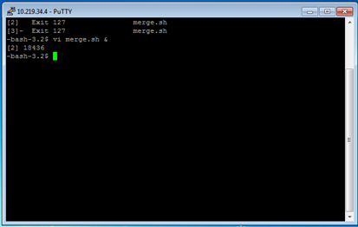

To run a process in the background ‘&’ operator is used

The shell script command to run “merge.sh” in the background is : vi merge.sh &

2.

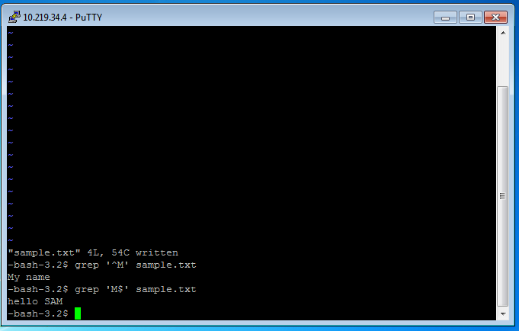

To find out the lines containing ^M characters at the end of every line grep command is used

^M - gives the lines starting with M

M$ - gives the lines ending with character M

Syntax – grep ‘^character_to_be_searched/character_to_be_searched$’ filename.txt

Command used : grep ‘^M’ sample.txt

3.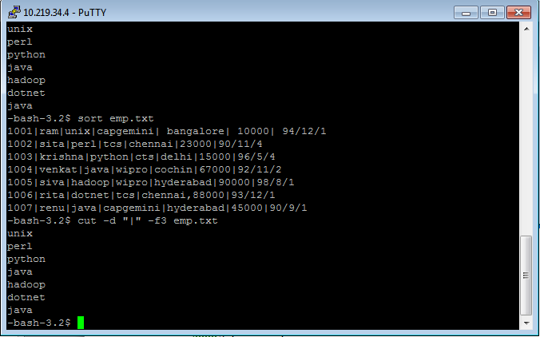

The command used to sort a pipe de-limited file as per the third column is :

sort emp.txt | cut –d “|” –f3 emp.txt

cut command is used to cut the fields vertically according to the delimiter specified

syntax: cut command_keyword “delimiter” –field_number filename.txt

Q2

4. #!/bin/bash

echo "enter username:"

read username

x=`date`

echo "enter any filename :"

read filename

if [ -e $filename ]

then

cat $filename

echo "file created by: $username"

echo "date and time of file creation is $x"

echo "size of the file is :"

else

echo "File doesnt exist.. please check"

fi

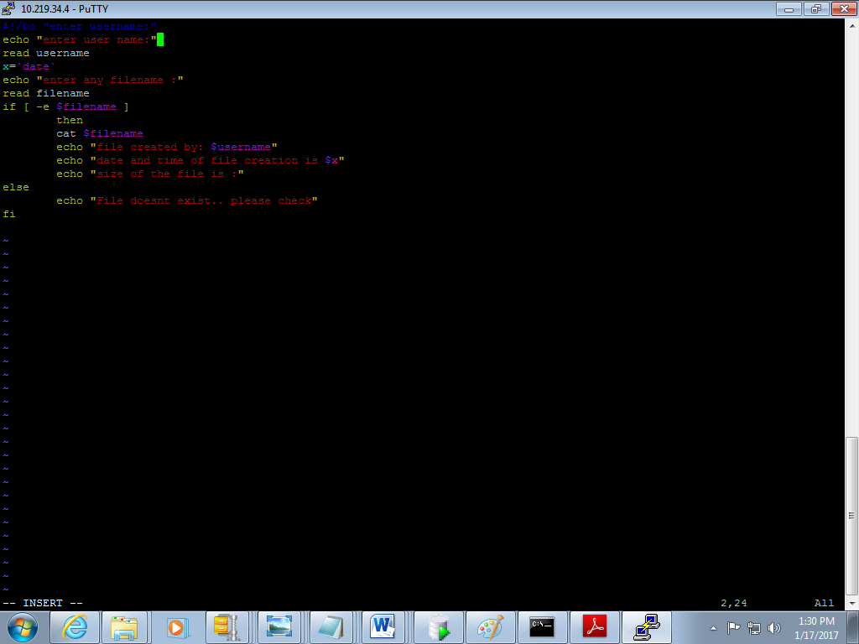

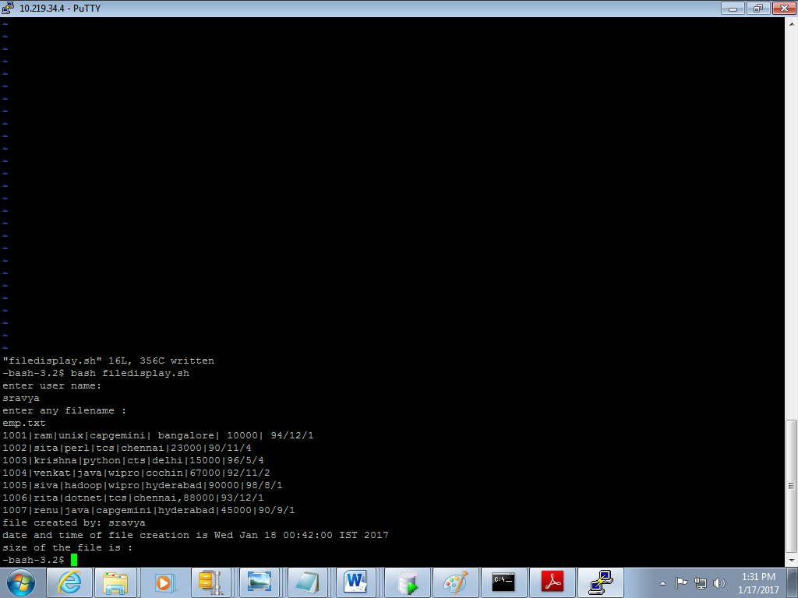

**SECTION 3 – ORACLE**

Q1

1.

SELECT s.staff_name,

ROUND(MONTHS_BETWEEN(SYSDATE,HIREDATE)/12) "Years of Experience",

ROUND(MONTHS_BETWEEN(SYSDATE,HIREDATE)) "Months of Experience"

FROM designation_master d,

staff_master s

WHERE s.design_code(+) = d.design_code

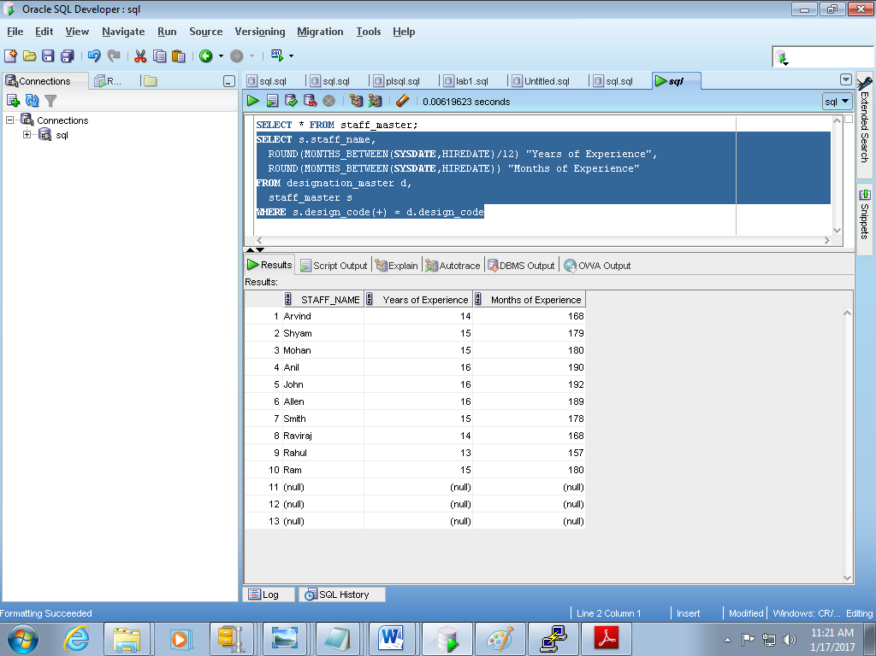

2.

SELECT staff_code "manager code",

staff_name "staff name",

staff_sal "salary of staff"

FROM staff_master

WHERE

staff_code NOT IN

(SELECT m.mgr_code

FROM staff_master s, staff_master m

WHERE s.staff_code ^= m.mgr_code

GROUP BY m.mgr_code

HAVING MIN(s.staff_sal)>15000

)

ORDER BY staff_sal DESC;

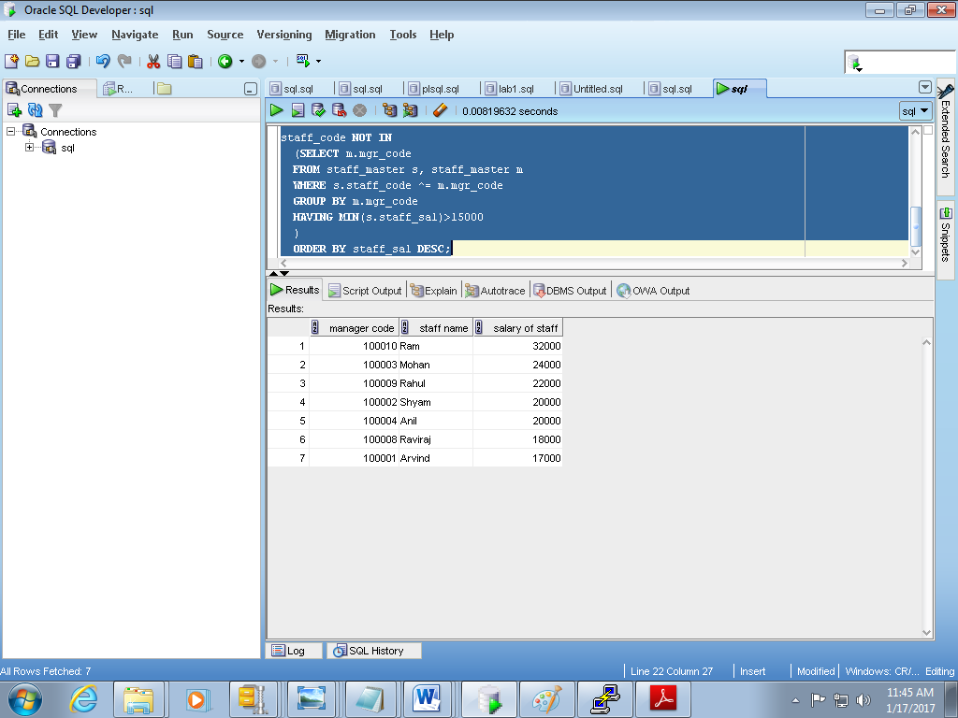

3.Since the staff_master table doesnot contain first name, last name and date of joining

Staff name, hire date and staff date of birth are considered

SELECT staff_name, hiredate, staff_dob

FROM staff_master;

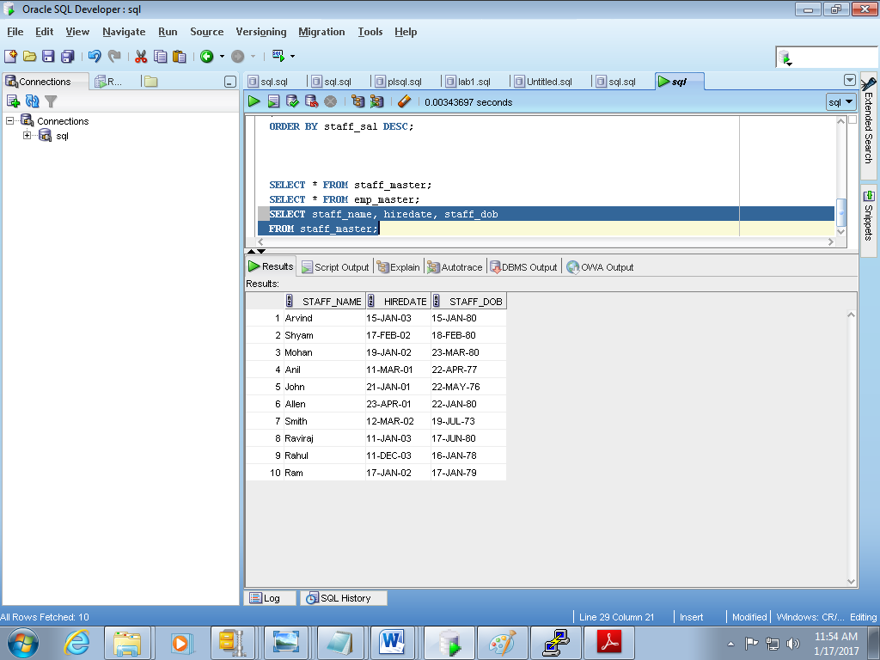

4.

select distinct s.staff_name, s.hiredate, s.staff_sal

from staff_master s, staff_master m

where s.staff_code ^= m.mgr_code;

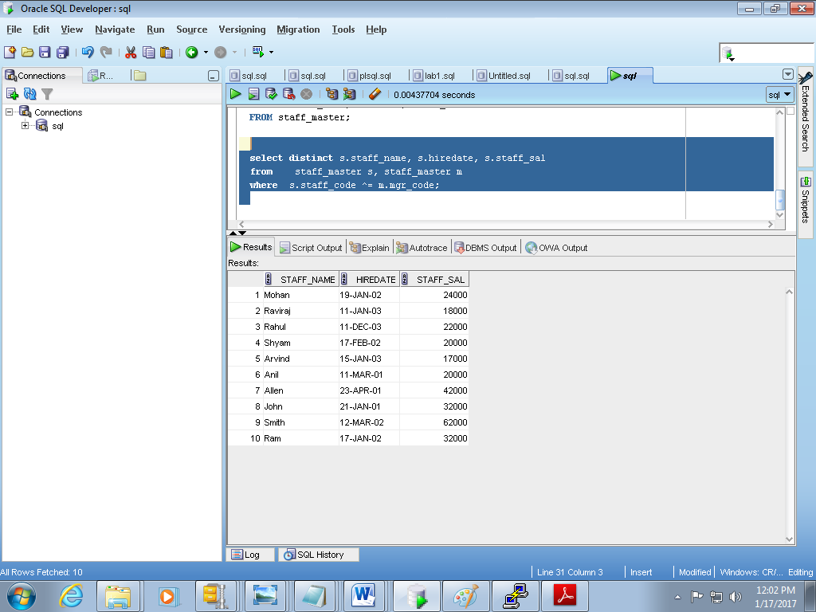

Q2

create or replace procedure salary_proc(p_deptno dept.deptno%TYPE) /*creating procedure*/

IS

v_deptno dept.deptno%TYPE;

v_sal emp.sal%TYPE;

v_exception EXCEPTION;

CURSOR c_sal IS SELECT sal FROM emp WHERE deptno = p_deptno;

BEGIN

OPEN c_sal;

LOOP

FETCH c_sal INTO v_sal; /*cursor value is fetched into v_sal */

IF c_sal%FOUND AND v_sal < 3000 THEN

UPDATE test_emp SET sal=sal+(sal*20/200) /*salary updated by 20% */

WHERE deptno =p_deptno;

ELSIF v_sal > 3000 THEN

UPDATE test_emp SET sal=sal+(sal*10/100) /*salary updated by 10% */

WHERE deptno = p_deptno;

ELSIF c_sal%ROWCOUNT =0 THEN

RAISE v_exception; /*raises an exception if c_sal%rowcount=0 */

END IF;

EXIT WHEN c_sal%NOTFOUND;

END LOOP;

EXCEPTION

WHEN v_exception THEN

DBMS_OUTPUT.PUT_LINE ('Exception handler - No Records Retrieved from the Cursor');

WHEN others THEN

rollback;

DBMS_OUTPUT.PUT_LINE('Error Encountered and the Error is - '||SQLERRM);

END

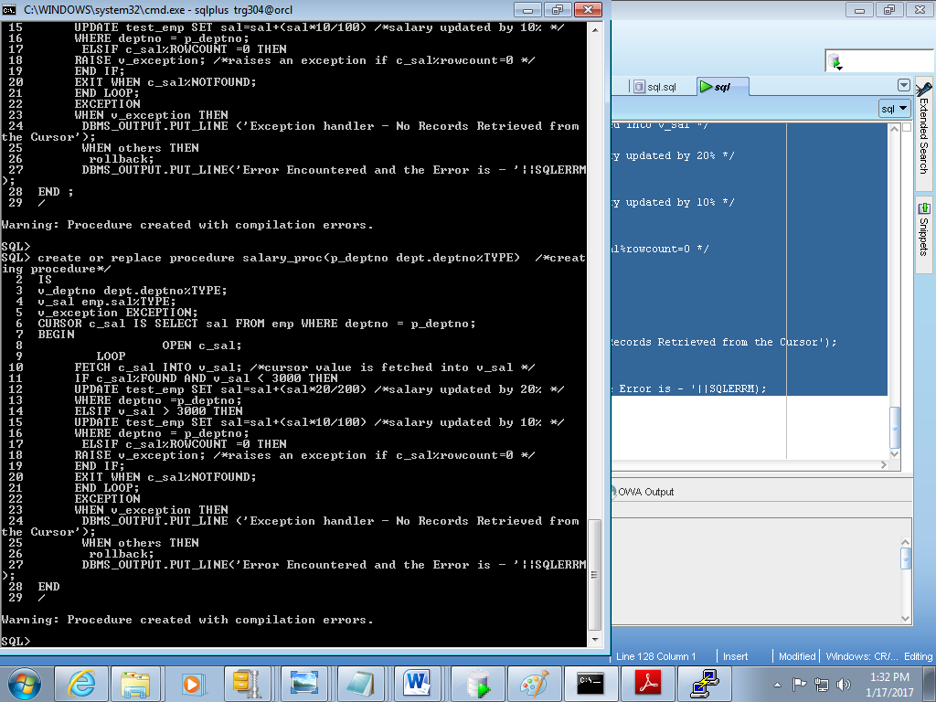

Q3.

CREATE OR REPLACE function sal_update_func(v_empno IN emp.empno%TYPE)

RETURN NUMBER AS

v_commission emp.comm%TYPE;

v_salary emp.sal%TYPE;

v_updated_sal emp.sal%TYPE;

BEGIN

SELECT comm,sal INTO v_commission,v_salary FROM emp

WHERE empno= v_empno;

IF(v_commission=0 OR v_commission IS NULL) THEN

v_commission:=((v_salary*5)/100);

v_updated_sal:=v_salary+v_commission;

ELSE

v_updated_sal:=v_salary+v_commission;

END IF;

RETURN v_updated_sal;

END;

EOF

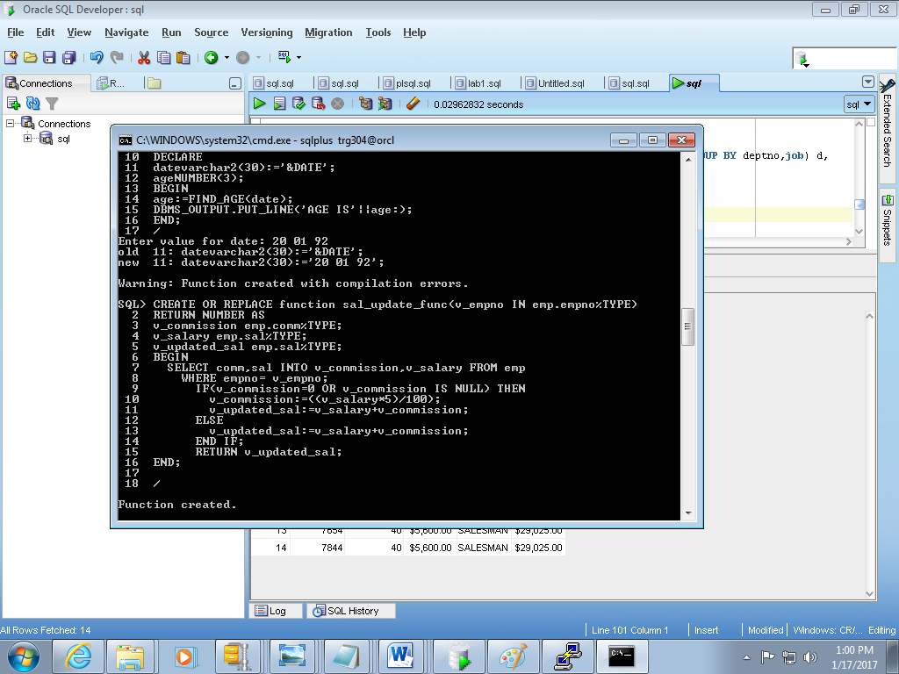

Q5.

SELECT e.empno,d.deptno,d.total,d.job,t.tot FROM emp e,

(SELECT TO_CHAR(SUM(SAL), '$99,999.00') AS total,deptno,job FROM emp GROUP BY deptno,job) d,

(SELECT TO_CHAR(SUM(SAL),'$99,999.00') AS tot FROM EMP) t

WHERE e.deptno=d.deptno and e.job=d.job

ORDER BY deptno;

